Observer pattern:

It has 2 entity

Subject: when something happens to it it notify all the observer.

Observer : Observer observes the subject continuously .

Eg: Shopping kart where in items are put in which list of the customer he will be notified when the item is back on the stock or price drop etc.

UML:

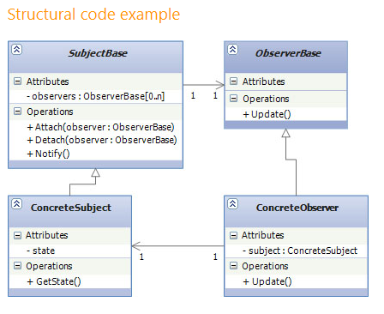

Command patter:

As a name suggest it encapsulate Actions inside the object. Using some command this actions can be executed

Sender receiver app